Association of Pakistani Physicians of New England : APPNE The New England Chapter

APPNE is a relatively new chapter comprising of physicians of the New England States of Massachusetts, Rhode Island,
New Hampshire, Vermont and Maine

Our goals for the year 2006-2007
A-Alliances: Increase membership of APPNA
P- Promote: Projects in Pakistan and here in the US
P- Provide: Platform for Physicians of Pakistani descent
N- Network: Assist our young physicians and medical students
E- Empower: Our local Pakistani community politically/socially

Alliances:
Naheed Usmani (past president) and Syed Iftikhar Hussain (current president) have been an immense source of encouragement and leadership for our small community; we share an atmosphere of free thought, ideas and opinions. This has set the foundation of a cohesive work environment and allowed area physicians to venture out on independent projects.

Providing a Platform:
-Our association has kept an open and proactive dialogue with the APPNA leadership. New England area Cardiologists have contributed towards APCNA (Association of Pakistani Cardiologists of North America).
Wajid Baig, Zia Kidwai and Nadeem Afridi have been an immense resource for improvement of cardiac care in Pakistan.
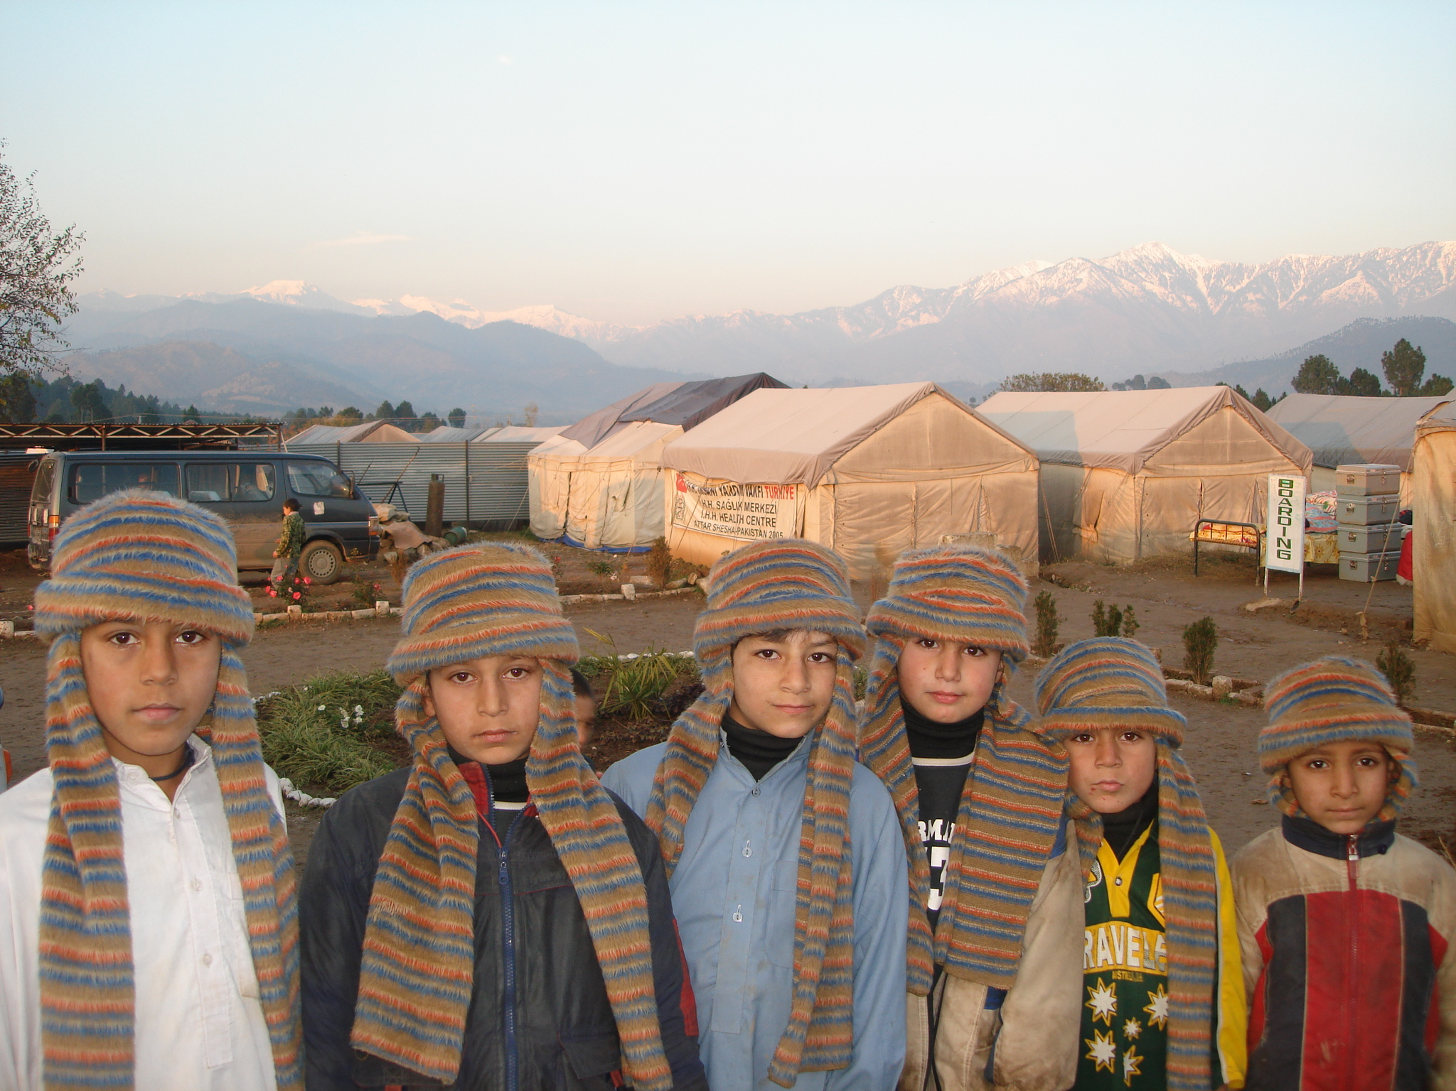

-Our ongoing collaboration with Indian medical Association of New England, and Massachusetts Medical Society raised invaluable support and funding for Earthquake relief activity in Northern Pakistan.
-Free Flu Vaccine Clinics were held at five separate area Islamic centers in Massachusetts and Rhode Island.

Promoting Projects
Earthquake Relief work:
-The establishment of a Disaster Mangement Center thru our collaboration with Abbottonian medical association(AMA)
and Ayub Teaching Hospital based in Abbottabad continues to provided immense logistical, medical and educational support to the earthquake affected population.

-A Scholarship Fund for Medical Students has provided support for over 60 deserving students.
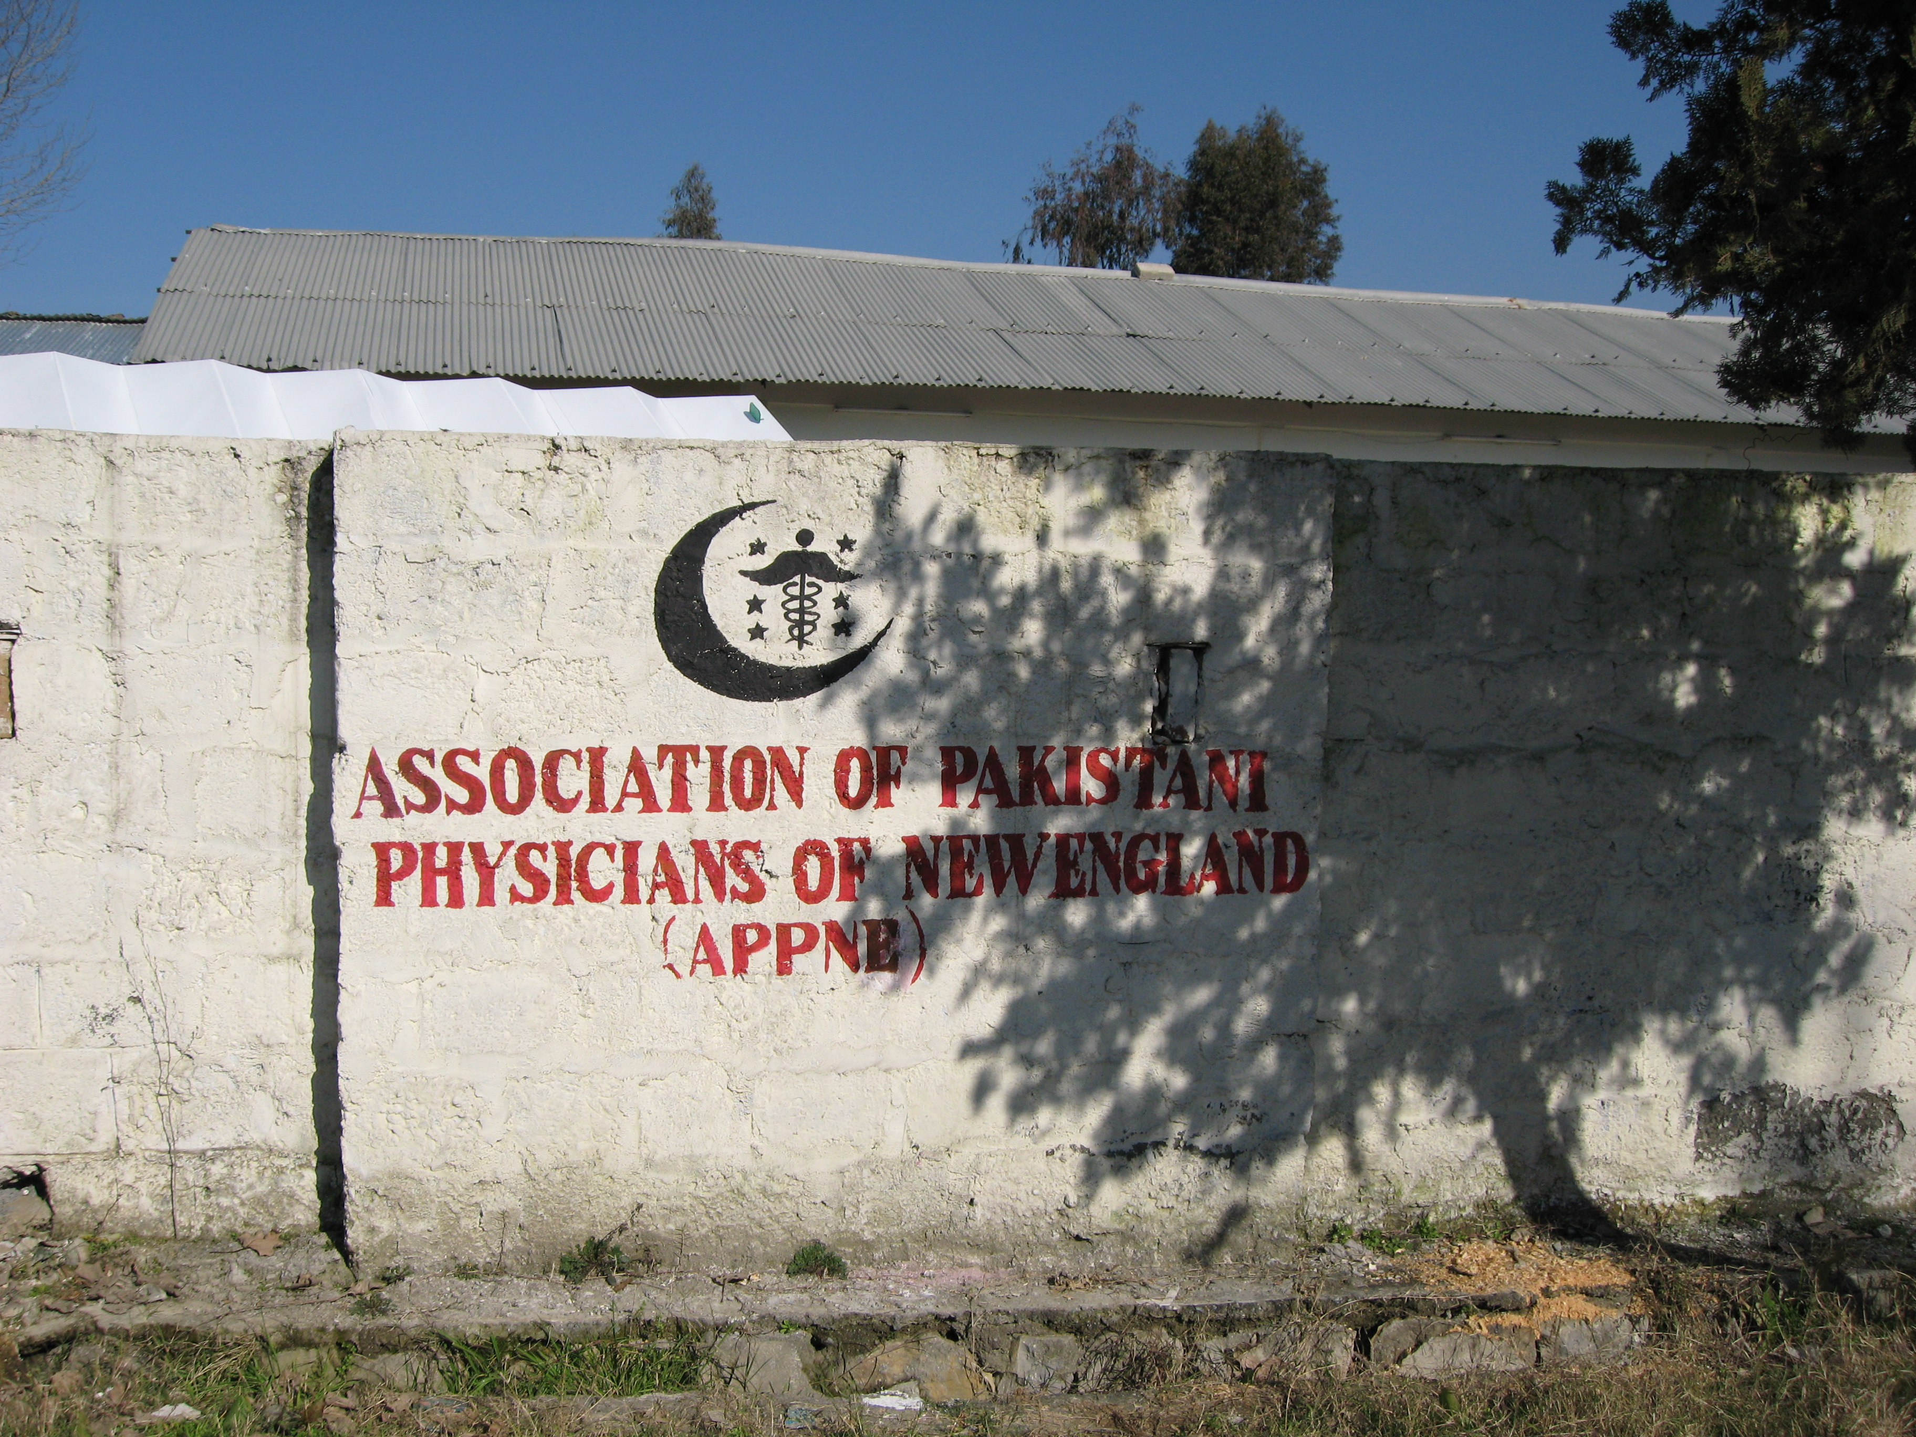
-Lectures and workshops have been held at the Disaster management center and Ayub teaching hospital.
Zahra Ayub and Batool Tauseef have held seminars on Neurological illnesses and Psychiatric disorders.
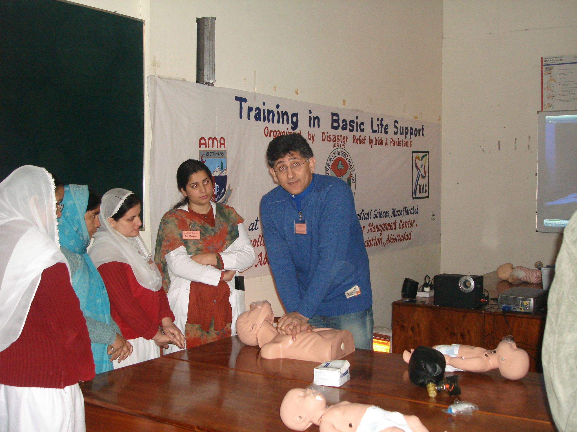
-Small scale projects funded by Fauzia Wali Khan and Nadeem Afridi included equipment support for Lighthouse school for the Blind and Kingston school for disabled children in Abbottabad.
-Their project for Basic life Support education and BLS training continues to provide Basic Life support education to area physicians, medical students, health care workers and teachers
-recent visit December 2006: orphanage “ashiana” catering to 200
orphans and widows. Plans are underway to provide assistance for
hot water and logistical support.
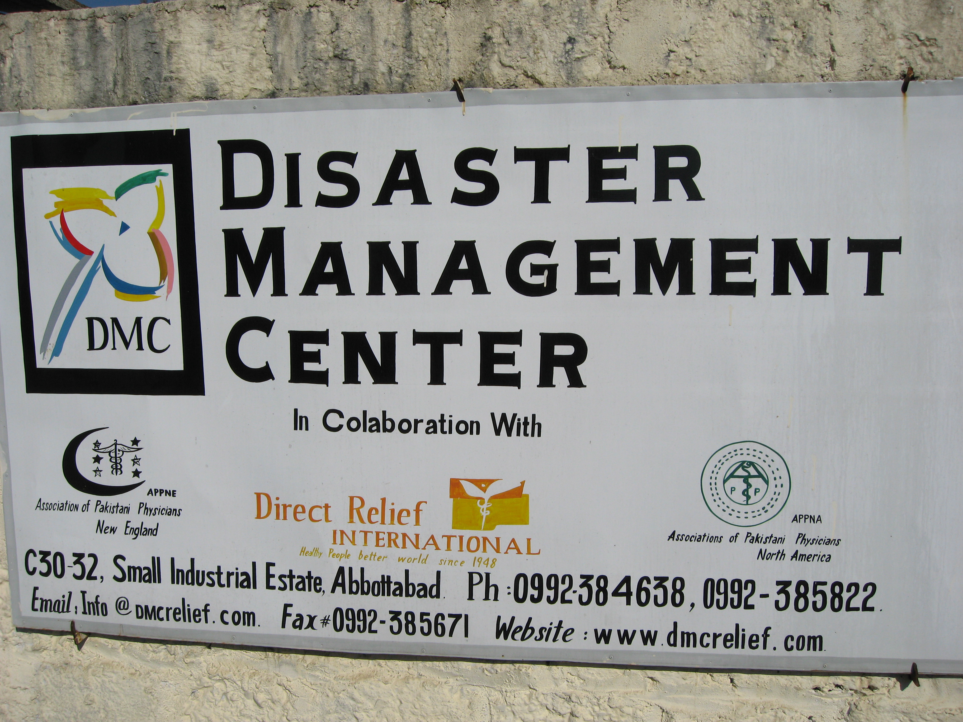
-APPNE members have also been an active part of local Rotary Clubs in Massachusetts and have spent countless hours at speaking assignments raising funds and matching grants for projects in Abbottabad. The partnership with the International Medical Equipment Collaborative (IMEC),has enabled us to send our first of four shipments of equipment to refurbish the Ayub teaching hospital on January 25th 2007.

Networking forYoung Physicians:
-Khalil Khatri and Iftikhar Hussain have set a good example of mentorship and their ongoing association with APPNA and the Young Physicians Mentorship Program. New England physicians in the field of academic medicine and psychiatry have been a steady source of guidance, logistical and academic support in assisting young physicians. Many have opened their homes and hearts out to these young graduates.

Empowering our community:
-APPNE wishes to acknowledge the tireless work of Hasan Usmani;a wizard at grant writing and Rotary member.
Shahid Ahmed Khan: always a great resource and liaison with local officials both in the US and in Pakistan.
-Pakistan Association of Greater Boston (PAGB): membership has been a steady partner in all events Pakistani.
-Pakistan Consulate: Barry Hoffman, and the Zalzala group initiative. The Consulates efforts in obtaining visa paperwork and coordinating travel plans gave the Boston community the opportunity to host a four year old child from Lahore, who had traveled to the US to undergo free Cardiothoracic surgery at the world renowned Children’s Hospital in Boston.
The professionalism, work ethics and contribution of physicians of Pakistani descent in the New England area local community has been well received.
This best encompasses the Spirit of New England

Report filed by: FauziaWali Khan.MD

